Motion

# Motion in 1 and 2 dimensions

km/h to m/s divide by 3.6

m/s to km/h times by 3.6

## Energy and Collisions

### Equations of motion

|  |  |  |
| --- | --- | --- |
| $$v=u+at$$ | t,u,v,a | x |
| $$x=ut+\frac{1}{2}at^{2} ∴t=\frac{±\sqrt{u^{2}+2ax}-u}{a}$$ | t,x,u,a | v |
| $$v^{2}=u^{2}+2ax$$ | x,u,v,a | t |
| $$x=\frac{1}{2}\left(u+v\right)t$$ | t,x,u,v | a |
| $$x=vt-\frac{1}{2}at^{2}$$ | t,x,v,a | u |

### Newtons laws of Motion

1. Every object continues to be at **rest**, or continues with a **constant** velocity, unless it experiences a **net force.**
2. The acceleration of a body experiencing a net force is directly proportional to the net force and inversely proportional to the mass i.e. $F=ma$
3. When one body exerts a fore on another body ( an action force), the second body exerts an equal force in the opposite direction on the first ( the reaction force) $F_{AB}=-F_{BA}$

Weight **W** in (N) on a body is the force of gravity i.e. $w=mg$

### Motion on Inclined planes

Weight **W** (down)

Normal reaction force **N** (normal to the plane)

The driving force **F**

The resistance force **f**

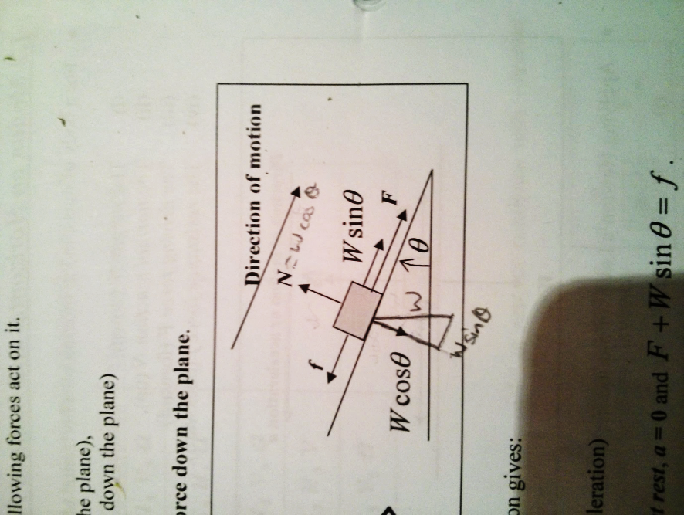

## Work Energy and Power

$W=F*x\cos{θ}$ Where $θ$ is the angle from the horizontal. Units **J**

**W** is the area under a Fx graph

$$Work done= ∆E_{kinetic}$$

## Energy

$$E_{kinetic}=\frac{1}{2}mv^{2}$$

$$U_{G}=mgh$$

$U_{Elastic}=\frac{1}{2}kx^2$

## Power

$$Power(W)=\frac{Work done(J)}{time(s)}$$

$$Power\left(W\right)=driving Force\left(N\right)*Constant Speed (ms^{-1})$$

# Hooke’s Law

$F=kx$ where k is the **spring** or **force constant**

A spring that obeys hooke’s law will have a linear Fx graph

k is the gradient of a Fx graph

Area under a Fx graph is the elastic potential energy.

# Momentum and Impulse

**Momentum $p$**  ($kgms^{-1}$)

$$p=mv$$

$$Impulse (I)= ∆p=m∆v=m(v_{2}-v_{1)}$$

$I=Ft$ $∴$ Area under Ft graph = impulse

## Collisions

Momentum conserved

If elastic kinetic energy is conserved.

# Projectile Motion

|  |  |
| --- | --- |
| Vertical Motion | Horizontal Motion |
| $$u_{v}=u \sin{θ}$$ $$a=-g$$ | Velocity $v=u\cos{θ}$ Displacement $x=$ $u\cos{θ}*t$ Time of flight $t=\frac{2u\sin{θ}}{g}$ |

$$x=\frac{-b±\sqrt{b^{2}-4ac}}{2a}$$

# Circular Motion

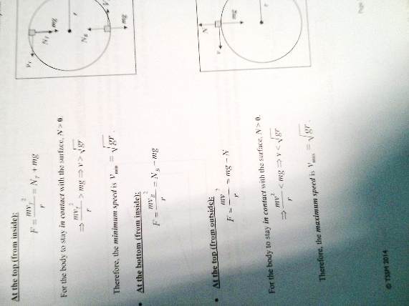

$$v=\frac{2πr}{T}, a=\frac{v^{2}}{r}$$

$$F=ma=\frac{mv^{2}}{r}=\frac{m*4π^{2}r}{T^{2}}=\frac{m*2πv}{t}$$

## Banked Plane

$$F_{g}=F_{Net}cos θ$$

$$F_{c}=F_{Net}\sin{θ}=\frac{mv^{2}}{r}$$

Max speed

$$v=\sqrt{gRtanθ}$$

# Gravity

$$F=\frac{GMm}{R^{2}}$$

$$G=6.67*{10}^{-11}$$

|  |  |
| --- | --- |
| Variables Used | Equations |
| a, R | $$a=\frac{GM}{R^{2}}$$ |
| v, R | $v^{2}=\frac{GM}{R}$ or $v=\sqrt{\frac{GM}{R}}$ |
| T, R | $T^{2}=\frac{4π^{2}R^{3}}{GM}$ or $T=\sqrt{\frac{4π^{2}R^{3}}{GM}}$ |
| a, V | $$a=\frac{v^{2}}{GM}$$ |
| a, T | $a^{3}=\frac{16 π^{2}GM}{T^{4}}$ or $a=\sqrt[3]{\frac{16 π^{2}GM}{T^{4}}}$ |
| v, T | $T^{2}=\frac{4 π^{2}G^{3}M^{3}}{v^{6}}$ or $T=\frac{2π}{v^{3}}\sqrt{G^{3}M^{3}}$ |

When orbiting the same thing: $$\frac{v_{1}}{v_{2}}={\left(\frac{R_{2}}{R_{1}}\right)}^{1/2}= {\left(\frac{T_{2}}{T_{1}}\right)}^{1/3}={\left(\frac{a_{1}}{a_{2}}\right)}^{1/4}$$

$M_{Earth}=5.98*{10}^{24}$, $R_{Earth}=6.37*{10}^{6}$

Electronics & Photonics

# Definitions

Sound

* Longitudinal wave ( compressions and refractions)

# Formulas

**Frequency-Period**: $f=\frac{1}{T}$, where **f** is the frequency and **T** is the period.

**Wave Equation**: $v=fλ$, where **v** is the sound waves velocity **f** is the frequency and **λ** is the wave length.

**Sound Intensity**: $=\frac{P}{r^{2}}$, where **I** is Sound Intensity, **r** is distance from audio source, and **P** is acoustic power of source.

**Decibel to Sound Intensity**: $I=I_{0}*{10}^{\frac{L}{10}}$, where **I** is the Sound Intensity, $I_{0}$ is the threshold frequency (${10}^{-12} Wm^{-2}$)

**Sound Intensity to Decibel**: $L=10*\log_{10}{(\frac{I}{I_{0}})}$

**Strings / both ends open** - all harmonics (n=1,2,3,etc) for pressure variation nodes near both open ends

$λ_{n}=\frac{2L}{n}, f_{n}=\frac{nv}{2L}=\frac{n}{2L}\sqrt{\frac{T}{M}},v=\sqrt{\frac{T}{M}}$ where, **n** is the harmonic #, **L** (m) is the speed of propagation and **M** (kg/m) is mass per length

**Closed –** only odd harmonics ( n= 1,3,5,etc) for pressure variation antinode near closed end - node near open end

$$λ_{n}=\frac{4L}{n}, f_{n}=\frac{nv}{4L}$$

For both closed and open: $f_{n}=n*f_{1}$

|  |  |  |
| --- | --- | --- |
| **Mic**. | Principal and Comments | |
| Electret Condenser | * Utilises a capacitor * Requires a Power supply. * Excellent frequency response. | * Expensive. * Vibrations change space between plates of capacitor |
| Ribbon  /Velocity | * Electromagnetism * Very sensitive. | * Highly directional |
| Dynamic | * Electromagnetism * Relatively cheap. * Very robust. | * Easily miniaturised. * Frequency response not as good as ribbon or condenser. |
| Crystal | * Utilises a piezoelectric crystal * Relatively cheap. | * Comparatively large electrical output. * Not used as much as other microphones. |
| Carbon | * Utilises carbon granules * Cheap * High level response | * Narrow frequency range * Used to be widely used in telephones |

1000Hz = Phon line

$I=sound intensity$,

$L=sound level$,

$$r=distance$$

$$I∝\frac{1}{r^{2}}$$

$$\frac{I_{1}}{I_{2}}={\left(\frac{r_{2}}{r_{1}}\right)}^{2}$$

$$\frac{I_{1}}{I_{2}}={10}^{∆L/10}$$

$$\frac{r_{1}}{r_{2}}={10}^{∆L/20}$$

$$∆L=10*\log_{10}{\frac{I_{1}}{I_{2}}}=20*\log_{10}\left(\frac{r_{1}}{r_{2}}\right)$$

dark current – in photodiodes

The current that flows when reverse biased while no light falls on the diode. It is very small, well under a microamp.

Clipping

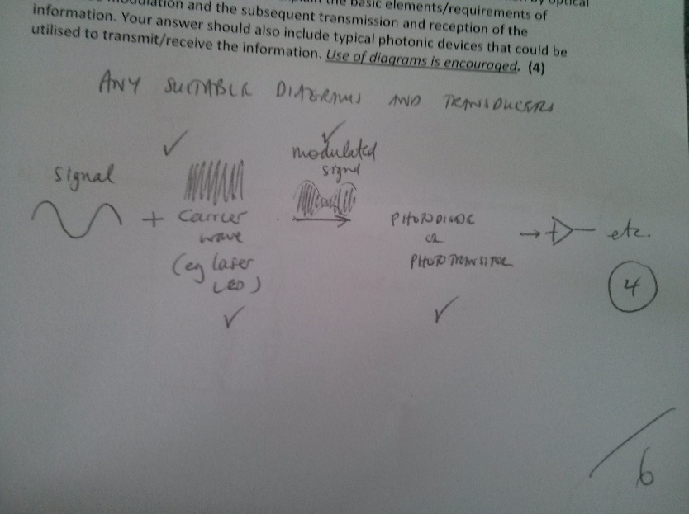Non-linear amplification that results in signal distortion, in which the peaks of the output waveform are limited (usually to the positive and/or negative power supply voltage).

Modulation

Laser diodes, like LEDs, can convert a change in the diode current directly into a change in light intensity. The change in light intensity is directly proportional to the change in current and this can be used as a method of imprinting information onto the light beam in laser telecommunications applications. This process is known as intensity (or amplitude) modulation, as the information signal modulates (or directly changes) the intensity of the laser diode’s light output

Demodulation

Demodulation is the act of extracting the original information-bearing signal from a modulated carrier wave. A demodulator is an electronic circuit (or computer program in a software-defined radio) that is used to recover the information content from the modulated carrier wave

# Formulas

$gain=\frac{∆V_{out}}{∆V_{in}}$**watch units mV?**

## http://media.paisley.ac.uk/~davison/labpage/tube/IMG00001.GIFVoltage Dividers

|  |  |
| --- | --- |
|  |  |
|  |
|  |
|  |

|  |  |  |
| --- | --- | --- |
| Light’s Properties | Particle Model | Wave Model Constants $$speed of light c=3*{10}^{8}$$ $$charge of electron e=1.6*{10}^{-19}$$ $$mass of electron=9.1*{10}^{-31}$$ $$h = 6.63* {10}^{-34} J s$$ $$h = 4.14* {10}^{-15}eV s$$ |
| Travels in Straight Lines | **Yes** | **Yes** |
| Reflection | **Yes** | **Yes** |
| Refraction: Snell’s Law | **Yes** | **Yes** |
| Diffraction | No | **Yes** |
| Colours | No | **Yes** |
| Crossing without collision | No | **Yes** |
| Interference | No | **Yes** |
| Refraction: $v∝\frac{1}{n}$ | No | **Yes** |
| Black-body radiation | **Yes** | No |
| Photoelectric Effect | **Yes** | No |
| Compton scattering | **Yes** | No |

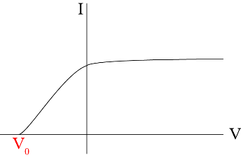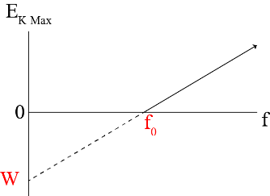

# Formulas

|  |  |  |  |
| --- | --- | --- | --- |
|  | **Particles** | **Photons** | **Matter Waves** |
| **Mass** | $$m$$ | No mass | $$m$$ |
| **Speed** | $v$*note: always < c* | $$c=fλ$$ | $v$*note: always < c* |
| **Frequency** |  | $$f=\frac{c}{λ}$$ |  |
| **Momentum** | $$p=mv=\sqrt{2mE_{k}}$$ | $$p=\frac{h}{λ}=\frac{hf}{c}=\frac{E_{k}}{c}$$ | $$p=\frac{h}{λ_{deBroglie}}$$ |
| **Wavelength** |  | $$λ=\frac{c}{f}$$ | $$λ_{deBroglie}=\frac{h}{mv}=\frac{h}{\sqrt{2mE_{k}}}$$ |
| **Energy** |  | $$E_{ }=hf=\frac{hc}{λ}=pc$$ |  |
| **Kinetic Energy** | $$E_{k}=\frac{1}{2}mv^{2}=\frac{p^{2}}{2m}=hf-W$$ |  |  |

* 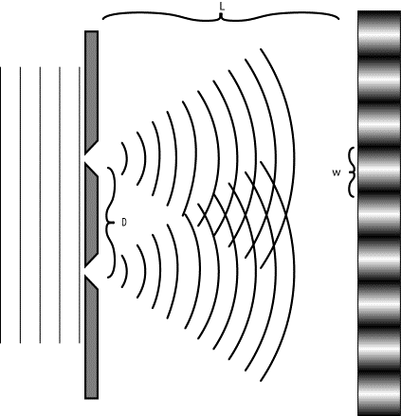Work Function $W=y_{int}=hf_{0}=h*x_{int}$ on EK max v.s. f graph
* Max $E_{k}=hf-W=eV_{0}$ where f is frequency and W is work function.
* Diffraction: “spreading of waves into the ‘shadow’ region when the waves go through n opening or when they meet an obstacle (eg microscope).
  + $Diffraction ∝\frac{λ}{w}$ where w is the slit width
$Diffraction is significant if \frac{λ}{w}≥1$

* Path Difference:
  + Constructive Interference (anti-node) $PD=nλ$
  + Destructive Interference (nodes) $PD=(n-\frac{1}{2})λ$
* Fringe Width $w=\frac{Lλ}{d}$, w is the fridge width, d is the distance between the gaps and L is the distance between the gaps and the ‘screen’

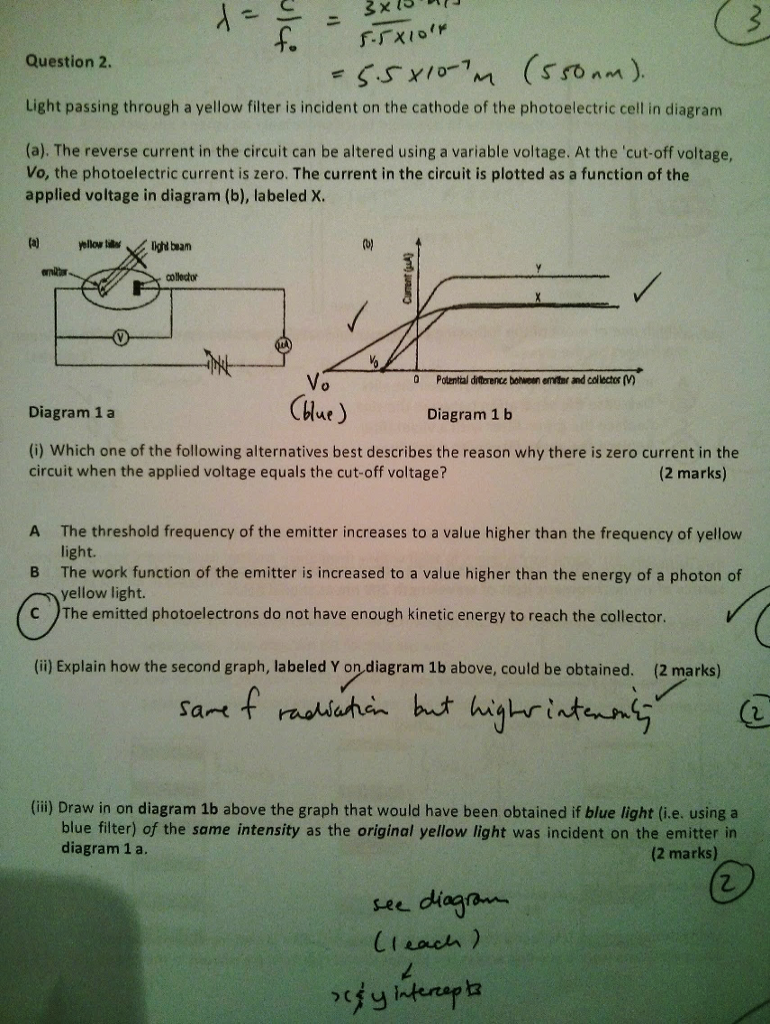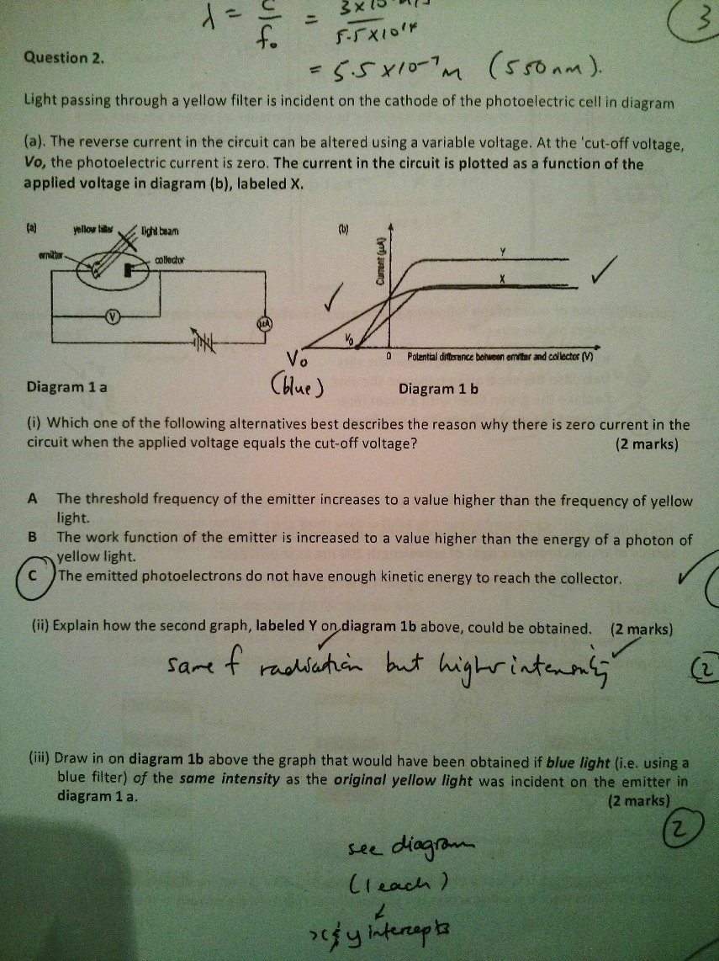

# Things to Check

* Graph parts: Titles (title and axes), error bars, units.

# Electro Magnetic Spectrum

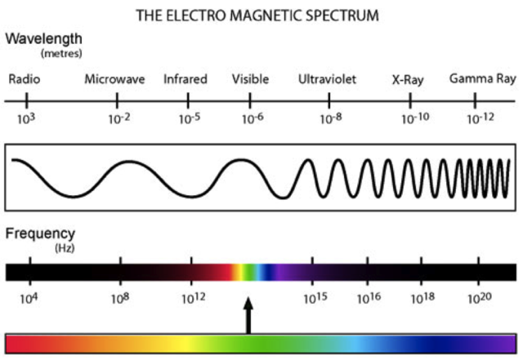

Magnets

# Formulas

## Alternating Voltage and Current

$V_{RMS}=\frac{V_{peak}}{\sqrt{2}}$, same for current

## Magnetic Force

$F=nBIL sinθ$ where F is Force (N), n is number of turns, B is magnetic field (T), I is current (A) and L is length of wire (m).

## Force on Moving Charge

$F=qvBsinθ$ where F is Force (N), q is the charge (C), v is the velocity ($ms^{-1}$) and B is magnetic field (T).

## Magnetic Flux

$Φ_{B}=BA_{⊥}$ where Φ is magnetic flux (Wb) or (Vs), B is magnetic field (T), A is area ($m^{2}$).

## Induction (my name for it)

$I∝\frac{∆Φ}{∆t}$ where I is current (A), where Φ is magnetic flux (Wb) or (Vs) and t is time (s).

## Faraday’s Law - magnitude

* The ***electromotive******force*** (***EMF***) is the *induced* ***voltage*** in a loop due to the *change* in the ***magnetic flux*** through it.
* As a ***conductor moves*** through a ***magnetic field***, ***work is done*** on the ***moving charges*** to produce the ***EMF***.
* Graphically, on a graph of $Φ_{B}=f(t)$, $E= -f'(t)$.

$E= -n\frac{∆Φ}{∆t}=BLv$ where E is the EMF (V), n is number of turns, Φ is magnetic flux (Wb) or (Vs), t is time (s) and v is speed in (m/s).

Wordy

*The induced EMF is directly proportional to the rate of change of the flux.*

Proofs

* 2nd peak larger in amplitude (EMF), because $\frac{∆Φ_{B}}{∆t}↑$

### Lenz’s Law

Wordy

* *Any* ***induced current*** *in a loop will be in the direction such that the* ***flux*** *it creates will* ***oppose*** *the* ***change in the original flux*** *which produced it.*
* *The induced current will flow in such a way as to oppose “whatever” caused it*.

Proofs

* Peaks in opposite direction 🡪 emf induced to oppose change

## Transformers

* For Ideal Transformers ie No loss of power:

$P_{p}=P_{s}=V_{p}*I_{p}= V_{s}*I_{s}$

$\frac{V_{s}}{V_{P}}=\frac{I_{p}}{I_{s}}= \frac{N_{s}}{N_{P}}$

# Things to Check

* Used right hand rule for rules NOT LEFT.
* Added $\overset{⃑}{B}$ for magnetic fields.

# Past Questions

## Field Lines overlap

If they overlap it implies a compass needle can point in two directions at the same time! i.e. it defies the vector nature of $\overset{⃑}{B}$.

## Induction in wire

Using the “right hand pistol rule” as the wire moves downwards and EMF is induced to set up a current flowing *from B to A.*

## Transformers – how they work.

* Changing current (AC) in the primary coil induces 🡪 . Which is transferred to the 2nd coil via the soft iron core.
* $∆Φ$ in 2nd coil 🡺 EMF induced (as $E= -n\frac{∆Φ}{∆t}$)

## Motor – ferromagnetic material

* Coil does not need to be ferromagnetic.
* Gold is a good conductor and will reduce the resistance of the coil hence increase the current.

## Power loss – transmission lines

Explain why voltage dropped when she turned the appliances on

With large currents (now being drawn by the appliances), voltage and hence power losses ( $IR$& $I^{2}R$) are significant 🡺.

## Ways to increase magnetic field strength

* Place soft iron core inside cylinder
* Move coils closer to point
* Increase # of coils
* Increase current flow

# Motors and Generators

* Slip rings for AC
* Split ring commutators for DC